YUEDU Shredders · Acetate Fiber Crushing and Baler Machine

Specialized Processing Equipment for Cigarette Filters
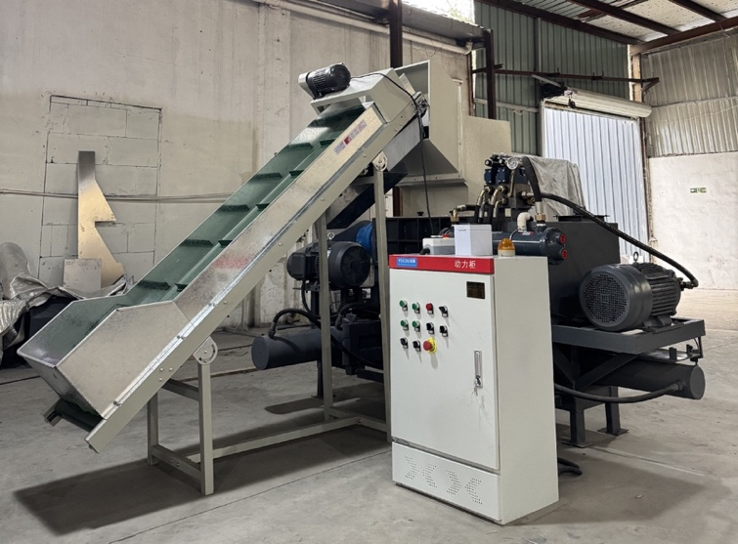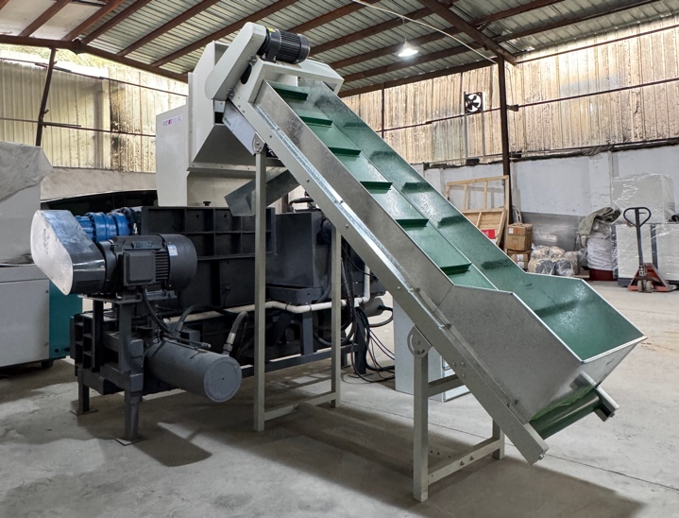

I. Product Overview
This equipment is specially designed for discarded cigarette filters (acetate fiber material) in cigarette factories, integrating confidential crushing + automatic baling and compacting functions. It replaces the traditional ink-splashing treatment process, realizing efficient recycling and reuse of cigarette filter waste, significantly reducing labor costs and increasing the added value of waste recycling. It is suitable for cigarette manufacturers, waste recycling enterprises and related processing institutions around the world.

II. Core Functions
- Confidential Crushing Treatment: Adopts high-precision crushing structure to refine acetate fiber cigarette filters, ensuring complete destruction of information and meeting the confidential destruction standards of cigarette factories and relevant international environmental protection and confidentiality requirements.
- Automatic Baling and Compacting: The crushed materials are automatically compressed into shape. The standard bale size is 300×300×300mm, and the size can be customized on demand, greatly reducing the volume and facilitating transportation, storage and reprocessing.
- Intelligent Control System: Equipped with an integrated control cabinet, supporting one-key start/stop and real-time monitoring of operating status, easy to operate and suitable for automated assembly line operations in global cigarette factories and recycling plants.

III. Product Advantages
- Industry Authority Verification: Has served China National Tobacco Corporation and many of its affiliated tobacco companies, and the stability and practicality of the equipment have been verified by leading customers. It conforms to international environmental protection standards and can meet the use needs of global cigarette manufacturers.
- Green and Environmentally Friendly Alternative: Replaces traditional ink-splashing treatment, no waste and no pollution, helping global cigarette factories and recycling enterprises achieve low-carbon and environmentally friendly production and comply with global environmental protection policies.
- Full Parameter Customization: Processing capacity 100kg/h–1t/h, crushing fineness minimum 1mm/powder, and bale size can all be customized to meet the diverse needs of customers in different countries and regions.
- Adaptation to Recycling Processes: According to the needs of downstream recycling and reprocessing processes around the world, crushing parameters can be customized to perfectly match the subsequent production processes, improving recycling efficiency.
- Integrated Cost Reduction: Integrated design of crushing and baling reduces floor space, simplifies production line configuration, and reduces comprehensive use costs for global customers.

IV. Application Scenarios
Suitable for centralized processing, confidential destruction and resource recycling and reuse of discarded acetate fiber cigarette filters in cigarette factories, waste recycling enterprises, and related environmental protection processing institutions around the world. It can also be used for the crushing and baling of other similar acetate fiber materials.

V. Equipment Component Details

1. Feeding Conveyor Belt (Model: YD‑XS500)
- Quantity: 1 unit
- Features: Equipped with a 200mm diameter metal magnetic roller, which can effectively absorb metal impurities mixed in materials, protect tools and ensure stable operation of the equipment, and adapt to the use environment of different regions.
- Function: Uniform and stable feeding to ensure the smooth operation of the entire production line.

2. Cigarette Filter Granulator (Model: YD‑XG600)
- Quantity: 1 unit
- Features: Specially designed for acetate fiber cigarette filters, with high cutting efficiency and strong stability, suitable for long-term continuous operation.
- Function: Pre-granulate cigarette filters to improve subsequent crushing efficiency and finished product fineness.

3. Double-Cylinder Hydraulic Baler
- Quantity: 1 unit
- Features: Double-cylinder hydraulic drive, large pressure, compact compression and good forming effect, which can adapt to the compression needs of different humidity and density of acetate fiber materials.
- Function: Compress the crushed fibers into standard bales, facilitating storage, transportation and improving recycling value.

VI. Frequently Asked Questions (FAQ)
Q: Can the processing capacity of the equipment be adjusted?
A: Yes. The capacity can be customized in the range of 100kg/h–1t/h to flexibly match the waste volume of factories in different countries and regions.
Q: Is the bale size fixed?
A: No, the size is not fixed. It can be customized to larger or smaller specifications according to the transportation and storage needs of global customers.
Q: What is the minimum crushing fineness?
A: The minimum fineness can reach 1mm, and it can also be processed into powder. Both shape and fineness can be customized according to customer needs.
Q: Can the equipment match the recycling and reprocessing process?
A: Yes. We will customize the corresponding crushing parameters according to the downstream recycling processes around the world to directly adapt to production.
Q: Is the operation complicated? Is professional training required?
A: The operation is simple. The intelligent control cabinet supports one-key start/stop, and ordinary operators can quickly get started without complicated training. We also provide English operation manuals and online guidance.
Q: Can it handle discarded cigarette filters with impurities?
A: Yes. The equipment can directly process standard acetate fiber cigarette filters, as well as waste with a small amount of packaging impurities, which is suitable for the actual waste situation of global customers.
Q: Are there any industry cooperation cases?
A: We have provided equipment for China National Tobacco Corporation and many of its affiliated tobacco companies, and have obtained high recognition from leading tobacco enterprises. Our equipment has the potential to serve cigarette manufacturers and recycling enterprises around the world.

📞 Contact Us

Johnny Deng, Managing Director
☎️ Phone: +86 159 0178 2779 (WhatsApp / WeChat / Facebook / Telegram)
📧Email: denghao8410@gmail.com

Shanghai YUEDU Technology Co., Ltd. (YUEDU Shredders)
🌐 Website(Global): www.yuedushredders.com (note: VPN required for China access, as the server is hosted by Google.)
📧 Email: yuedushredders@gmail.com / denghao8410@gmail.com
☎️ Sales Supervisor: +86 159 0178 2779 (WhatsApp / WeChat / Facebook / Telegram) ☎️ Administrative Supervisor: +86 137 6138 5116
☎️ Head Office Main Line: +86 21 519 000 20
📍 Company Headquarters: Building 12, No. 555 Chengyin Road, Baoshan City Industrial Park, Shanghai, China

Global Customer Usage Scenarios & Core Search Keywords

1. Global Customer Usage Scenarios
- Cigarette Manufacturers (Global): Used for centralized treatment and confidential destruction of discarded cigarette filters, complying with local environmental protection and confidentiality regulations, and realizing resource recycling to reduce costs.
- Waste Recycling Enterprises: Used for crushing and baling acetate fiber waste (including discarded cigarette filters, acetate fiber scraps, etc.), reducing transportation costs and improving the added value of recycled materials.
- Environmental Protection Processing Institutions: Used for the harmless treatment and resource utilization of acetate fiber waste, meeting international environmental protection standards.
- Related Industrial Enterprises: Used for the crushing and baling of acetate fiber materials in the production process, optimizing the production process and reducing waste.

2. Core Search Keywords (for Global Customers)
- Core Product Keywords: Acetate Fiber Crushing and Baler Machine, Cigarette Filter Crushing Machine, Acetate Fiber Baler, Confidential Crushing Equipment.
- Material-Related Keywords: Acetate Fiber Processing Equipment, Acetate Waste Crushing Machine, Cigarette Filter Recycling Equipment.
- Function-Related Keywords: Automatic Crushing and Baling Machine, Confidential Waste Destruction Equipment, High Precision Crushing Machine.
- Application-Related Keywords: Cigarette Factory Waste Treatment Equipment, Acetate Fiber Recycling Machine, Global Environmental Protection Processing Equipment.

