YUEDU YD‑SL60120 Large Inlet Plate Shredder


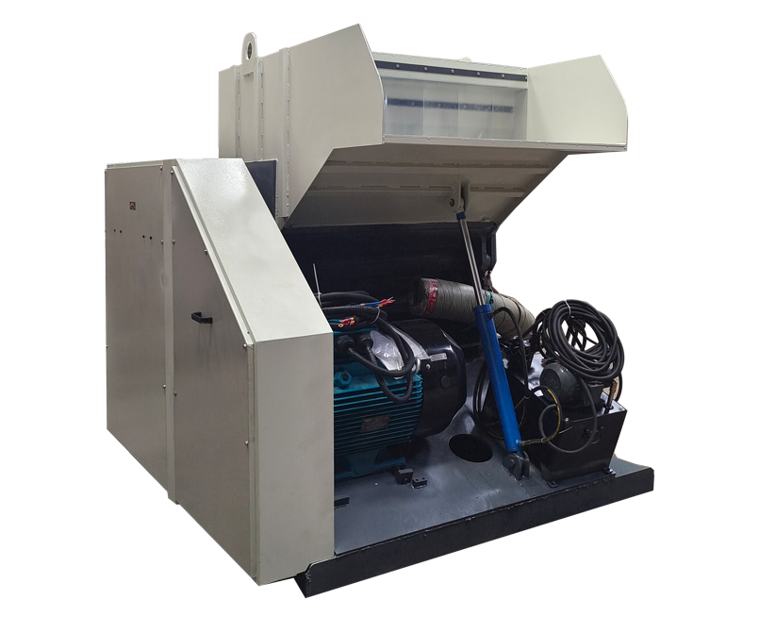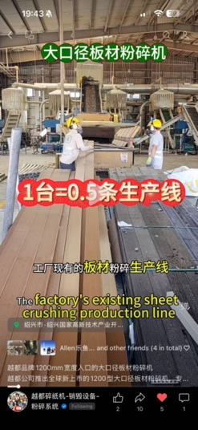

I. Product Positioning
Designed specifically for plates wider than 1 meter, it efficiently shreds plastic, rubber, PP boards, paper cartons, billboards, display boards, WPC/SPC floor scraps, etc. Suitable for 24-hour continuous operation in factories, making recycling and granulation more convenient.

II. Core Specifications
- Model: YD‑SL60120
- Inlet Size: 1200mm × 620mm
- Effective Knife Roller Width: 1200mm
- Knife Roller Diameter: 600mm
- Rotational Speed: 480RPM
- Blade Material: D2 (Sharpening recommended every 3 months for PP board working conditions)
- Discharge Size: 14mm (Customizable)
- Motor: 55kW Wolong (UK) Motor
- Capacity: 3000–5000kg/hour
- Overall Material: Steel Plate
- Overall Dimensions: 2m (L) × 2.14m (W) × 2m (H)
- Overall Weight: 7500KG

III. Application Scenarios
- Shredding of plastic plates, PP boards and rubber materials
- Destruction and disposal of billboards, display boards and conference display panels
- Recycling and granulation of WPC/SPC floor edge scraps and waste materials
- Shredding of cartons, paper and other materials

IV. Customer Case
Meixing Technology (Foshan, Guangdong) (A leading WPC/SPC floor manufacturer with an annual output of over 20 million square meters, exporting to Europe, America and the Middle East)
Used for efficient shredding of WPC floor edge scraps and waste materials in the production line, realizing recycling through granulation.
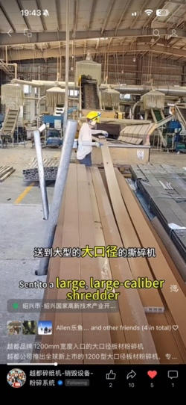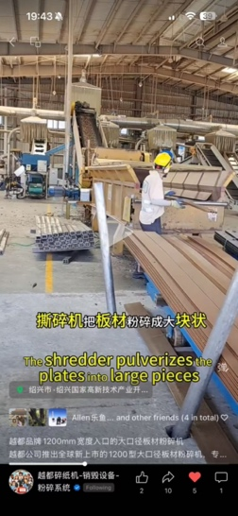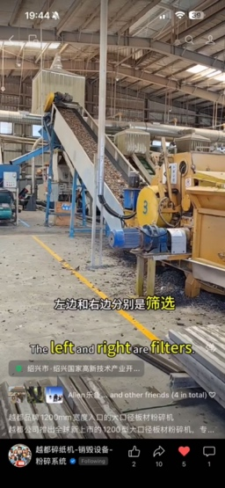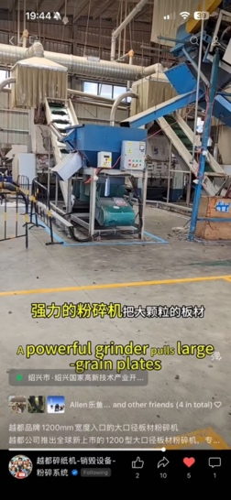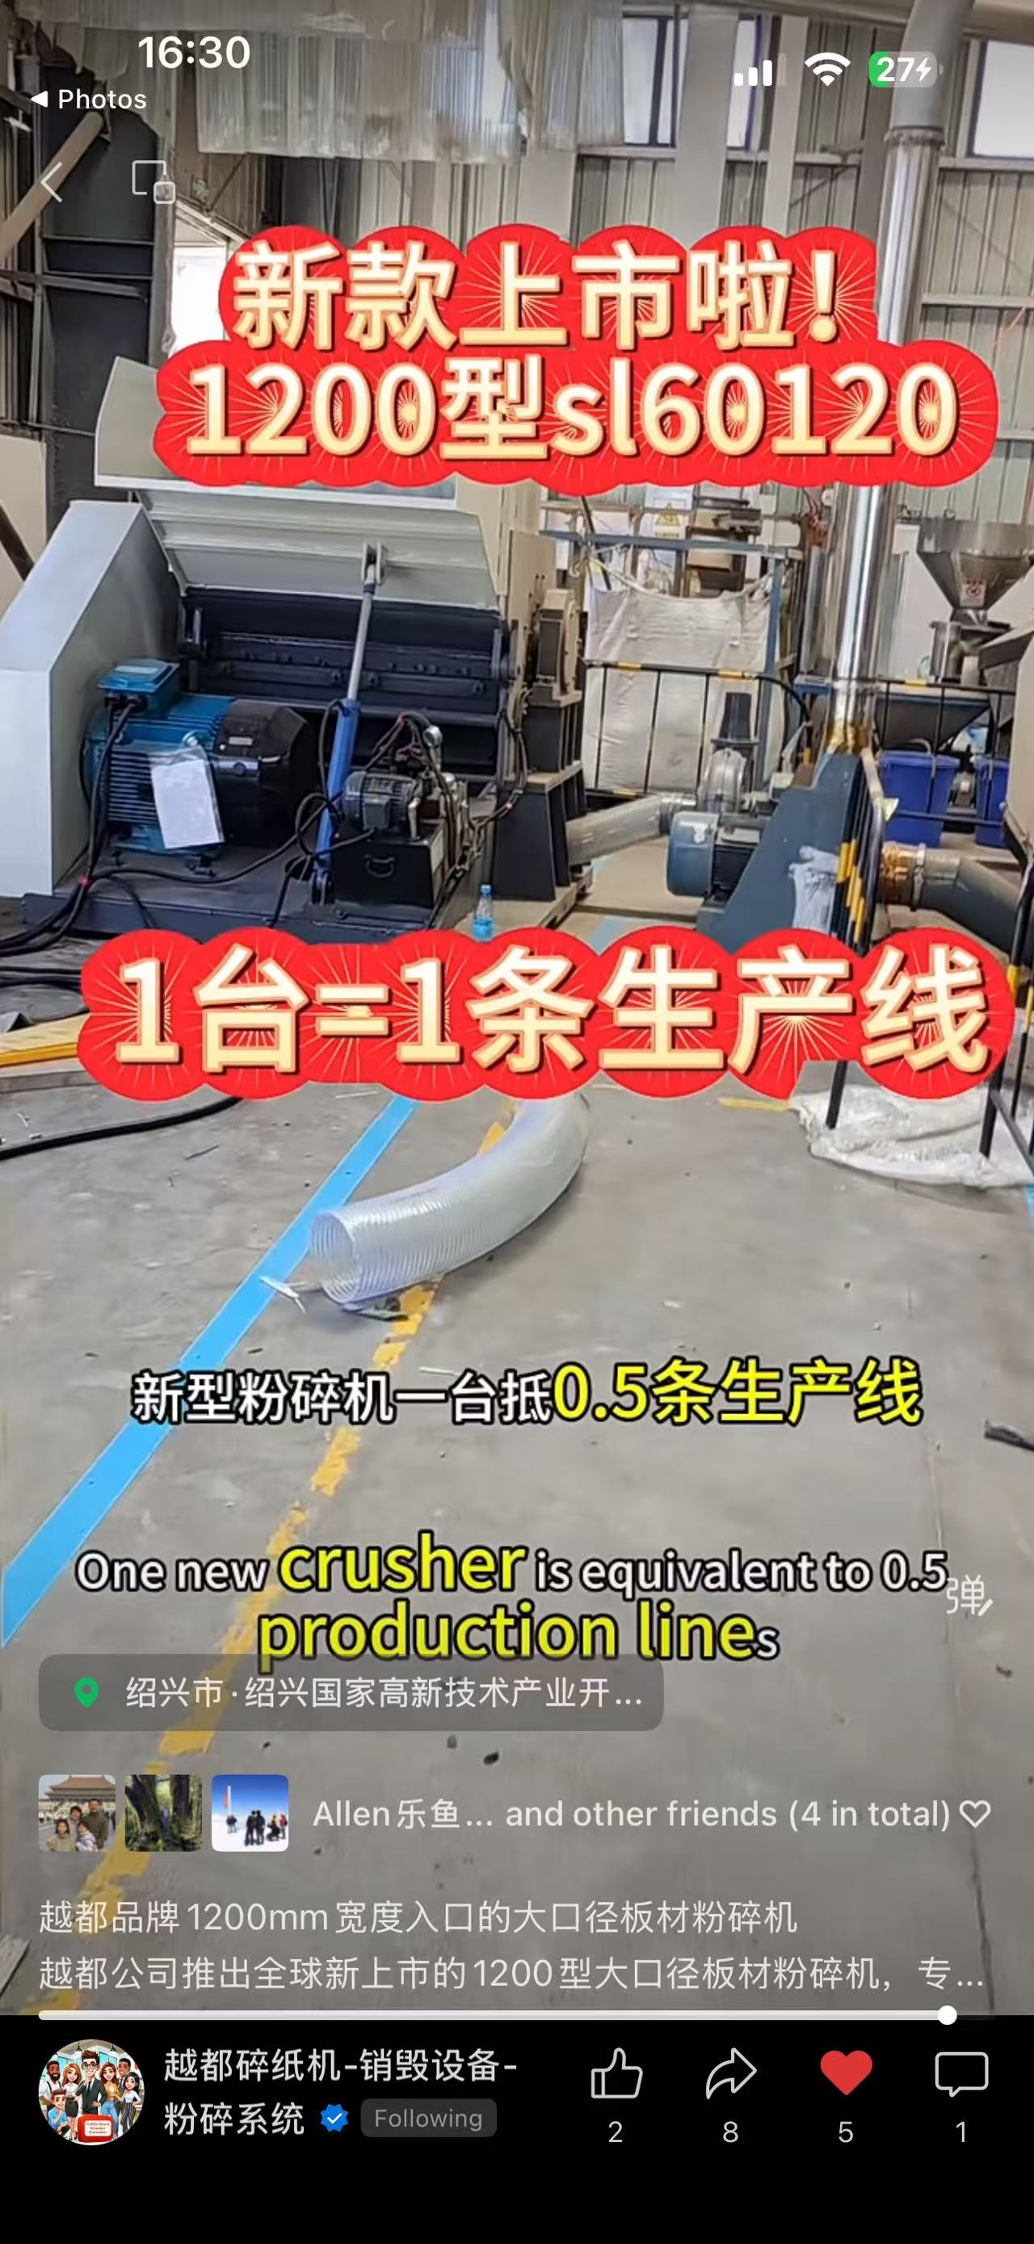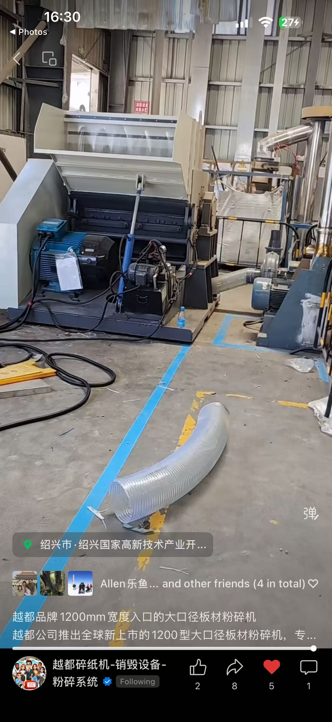
：https://youtu.be/tLL_YimCKvs

V. Product Highlights
- 1.2m large inlet, allowing direct feeding of wide plates without cutting
- High capacity and durability, suitable for 24-hour continuous production
- One machine replaces multiple recycling lines, cost-effective
- Adjustable discharge size to meet the requirements of recycling granulation
 | 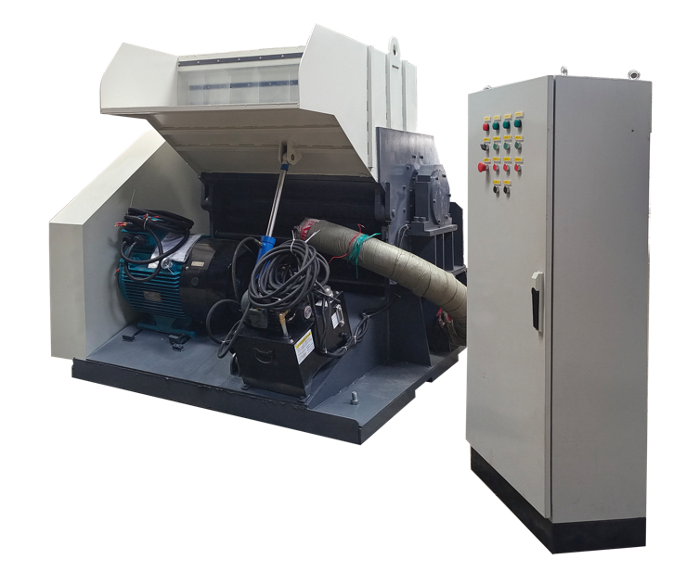
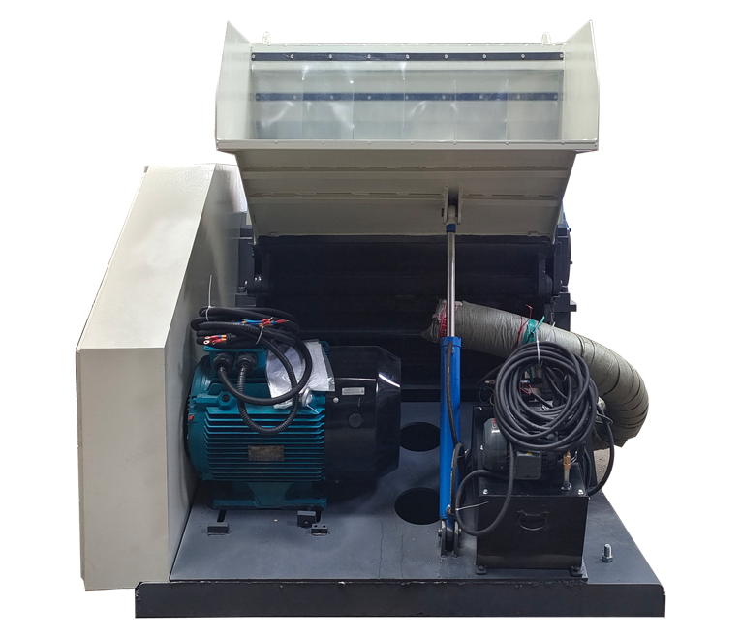 | 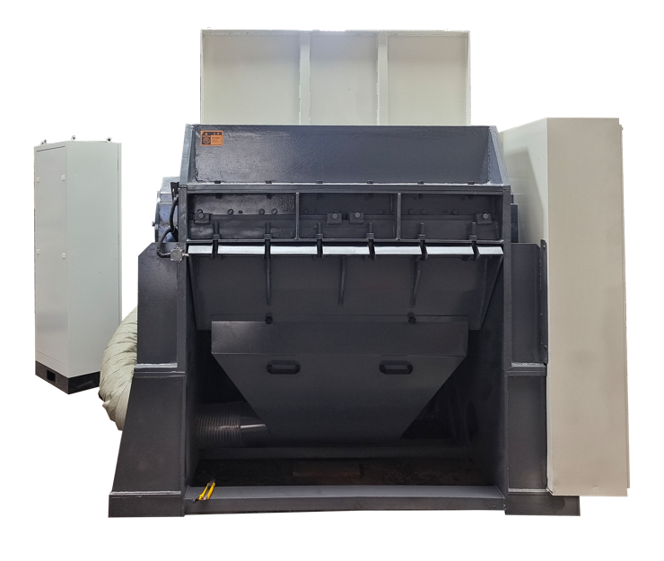

📞 Contact Us

Johnny Deng, Managing Director
☎️ Phone: +86 159 0178 2779 (WhatsApp / WeChat / Facebook / Telegram)
📧Email: denghao8410@gmail.com

Shanghai YUEDU Technology Co., Ltd. (YUEDU Shredders)
🌐 Website(Global): www.yuedushredders.com (note: VPN required for China access, as the server is hosted by Google.)
📧 Email: yuedushredders@gmail.com / denghao8410@gmail.com
☎️ Sales Supervisor: +86 159 0178 2779 (WhatsApp / WeChat / Facebook / Telegram) ☎️ Administrative Supervisor: +86 137 6138 5116
☎️ Head Office Main Line: +86 21 519 000 20
📍 Company Headquarters: Building 12, No. 555 Chengyin Road, Baoshan City Industrial Park, Shanghai, China

