Dust-Free Waste Paper Dry Pulping Production Line Configuration Proposal
Shanghai Yuedu Technology Co., Ltd.
Suiba (Shanghai) Crushing Equipment Center
Proposal Purpose: Dust-free dry pulping of waste paper, waste paper fiber loosening, zero-wastewater pulping, recycled fiber processing
1. Proposal Overview
This dust-free waste paper dry pulping line is specially designed by Shanghai Yuedu Technology Co., Ltd. for waste paper recycling and resource regeneration.
The whole line adopts closed conveying + water-resistance mist dust suppression to realize full-process dust-free operation.
The core pulping unit features variable-frequency drive and highly wear-resistant rotor structure, delivering uniform fiber loosening, no agglomeration, and low fiber damage. It can be directly used in papermaking, packaging, molding, and recycled fiber raw material applications.
Designed capacity: 10 T/H
High automation, stable running, easy maintenance, compliant with environmental protection, energy-saving and safe production requirements.

2. Detailed Equipment Configuration & Parameters
Item: Dust-Free Waste Paper Dry Pulping Line | Specification
Chain Plate Feeding Conveyor | Width: 1.2 m; Length: 10 m; Power: 3 kW
Double-Shaft Shredder | Width: 1.8 m; Power: 2×75 kW; Output size: 3–5 cm
Discharge Conveyor | Width: 1 m; Power: 3 kW
Electromagnetic Self-Discharging Iron Remover | Width: 1.2 m
Buffer Distribution Silo | Buffer space, balancing production line
Variable-Frequency Feeding Conveyor | Width: 0.8 m; Length: 5 m; Power: 2×2.2 kW
Pulping Machine | Power: 4×55 kW×2
Screw Feeder | Φ300×4 m × 4 sets
Water-Resistance Mist Spray System | Four functions: dust blocking, dust reduction, cooling, flame retardant
Baler | Bale size: 1100×1250×1500 mm
Capacity | 10 T/H
Total Power | 600.4 kW
Price (RMB) | 3,105,000
3. Customer Case: Tangshan Paper Industry

Business License (Official Chinese & English Translation)

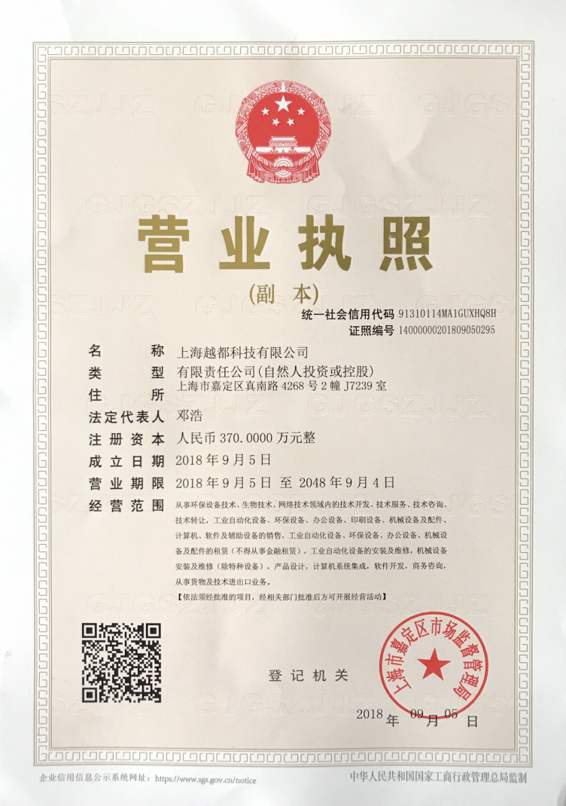 | Business License (Translated Version)  Shanghai Yuedu Technology Co., Ltd.   Company Information  Company Name:  Shanghai Yuedu Technology Co., Ltd.  Unified Social Credit Code:  91310114MA1GUXHQ8H  Company Type:  Limited Liability Company (Invested or Controlled by Natural Persons)  Registered Address:  Room 17239, Building 2, No. 4268 Zhen'nan Road, Jiading District, Shanghai, China  Legal Representative:  Deng Hao  Registered Capital:  RMB 3,700,000  Registration Details  Date of Establishment:  September 5, 2018  Business Term:  From September 5, 2018 to September 4, 2048  Registration Authority  Shanghai Jiading District Administration for Market Regulation  Date of Issue:  September 5, 2018

This document is a translated version of the original Chinese business license.
In case of any discrepancy, the original Chinese version shall prevail.
✔ Registered and verified company in China
✔ Officially issued by Chinese government authority
✔ Valid for international business cooperation

 Contact Us
Johnny Deng, Managing Director
 Phone: +86 159 0178 2779 (WhatsApp / WeChat / Facebook / Telegram)
 Email: denghao8410@gmail.com

Shanghai YUEDU Technology Co., Ltd. (YUEDU Shredders)
 Website(Global): www.yuedushredders.com
Email: yuedushredders@gmail.com / denghao8410@gmail.com

Sales Supervisor: +86 159 0178 2779 (WhatsApp / WeChat / Facebook / Telegram) Administrative Supervisor: +86 137 6138 5116
Head Office Main Line: +86 21 519 000 20

 Company Headquarters: Building 12, No. 555 Chengyin Road, Baoshan City Industrial Park, Shanghai, China
About YUEDE Shredders
Shanghai YUEDU Technology Co., Ltd. is a Shanghai-certified high-tech enterprise specializing in the development and manufacturing of shredding and destruction equipment. We serve a wide range of sectors including government agencies, financial institutions, military departments, enterprises, and recycling industries.
Our offerings include office and industrial-grade paper shredders, hard drive destroyers, plastic crushing systems, and fully customized destruction center solutions. From design to delivery, we help clients achieve efficient, secure, and compliant material destruction.
 Our Mission
We are dedicated to the shredding and destruction industry, continuously solving diverse material shredding and disposal challenges for our clients around the world.

